1.  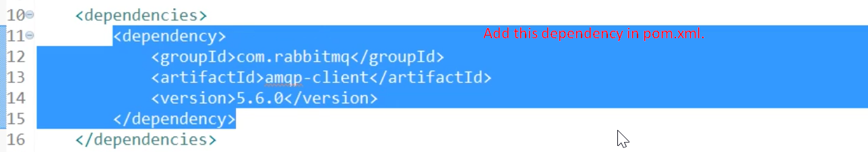
2. Using ConnectionFactory class, let’s create connection which is interface in RabbitMQ Client